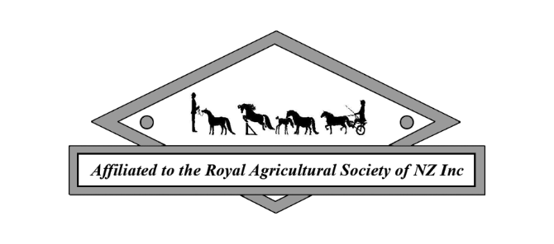
NZMHA AFFILIATED CLUB JUDGE APPROVAL REQUEST

CLUB NAME

SHOW DATE

SHOW RATING

SHOW LOCATION

TYPE OF SHOW (e.g. Single/Double Judge show; alongside another Affiliated Club Show or NZMHA Showcase Show)

NOMINATED JUDGE NAME

JUDGES ADDRESS

RESUME ATTACHED – YES / NO

CLUB CONTACT TEL NO

CLUB CONTACT EMAIL

ANY OTHER RELEVANT INFO

NZMHA USE:

Date approval application received

Is further info required?

LOC approval granted – Yes / No

Date Club advised

Date Show Committee Advised

